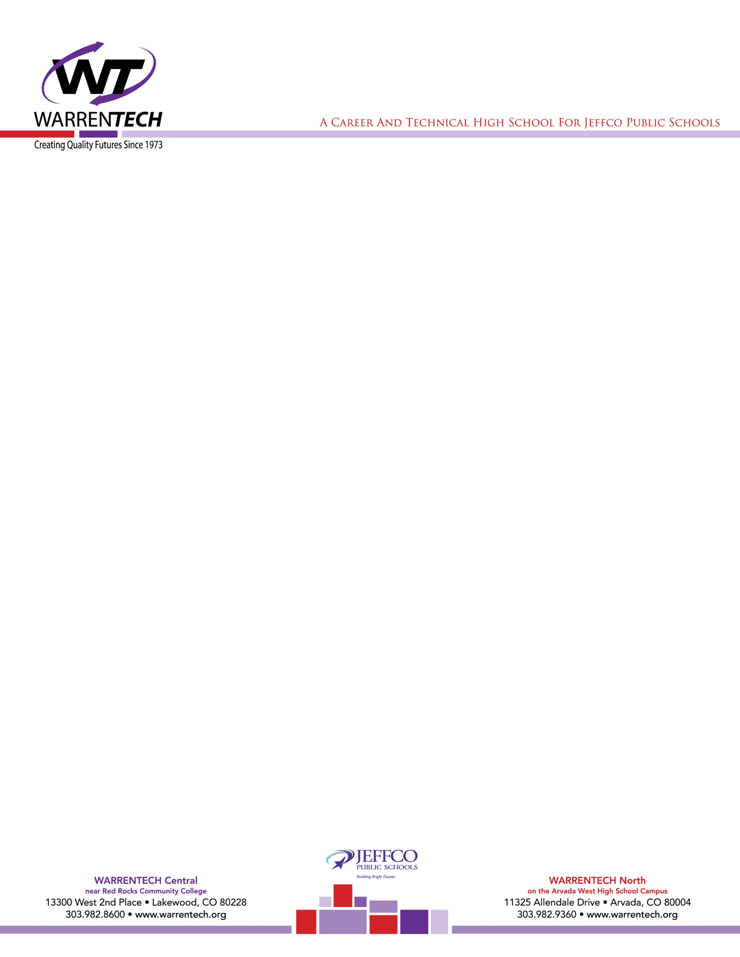

To Whom It May Concern  
RE: Kylan Coffey

It has been my pleasure to be Kylan Coffey’s Computer Science teacher during both his junior and senior years of high school.

Kylan has wonderful soft skills. He is incredibly intelligent, self-directed, perfection-driven, and has a very high aptitude for various computer technologies. He gets great grades in my class.

Kylan rapidly assimilates the ideas and technologies we have gone over in class. He has learned a variety of programming languages: Java, C++, Python, and web development languages such as HTML5, CSS3, and JavaScript. Kylan has taken quite an interest in developing scripts for pen-testing electronics such as the HakShop Rubber Ducky. He has been very successful in going through the required training for various CompTIA exams such as A+ and Network+. Kylan currently possesses TestOut PC Pro and Network Pro certifications. He is working on Linux Pro. There is little technology with which Kylan does not have a grasp.

Kylan has a multiplicity of technological strengths. He understands coding very well, and will have no trouble completing a Computer Science program. Conversely, he has keen knowledge and insight of PCs and the Windows operating system. It’s just a short jaunt for him to mastery of Linux. His Rubber Ducky scripting assignment fascinated him, and he has taken all different kinds of approaches to crafting a successful social engineering experiment using these devices. I could easily see him developing bash scripts, writing systems code, and developing applications.

I highly recommend Kylan Coffey for any technical endeavors he decides to pursue.

Sincerely,  
William (Bill) Heldman, Ph.D.  
Computer Science and Cybersecurity Instructor  
Warren Tech – www.warrentech.org  
13300 W. 2nd Pl.  
Lakewood, CO 80228  
303-982-8534  
wheldman@jeffco.k12.co.us